Dimensions of Diversity Pathways Grant Award | 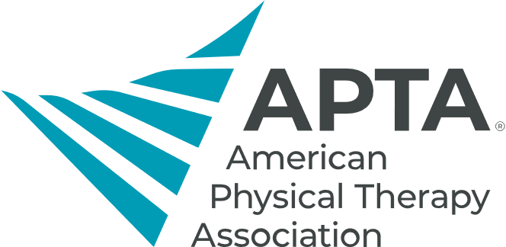
Application Form
Name:
Current Mailing Address:
City/State/Zip:
Permanent Mailing Address:
City/State/Zip:
Phone:
Email:
APTA member number:
PATHWAY PROGRAM INFORMATION (Note: If program is still in developmental phase, please provide any information currently available.):
Name of program:
Location of program. Please also include the geographic region it serves, if different then location:
Target audience for program:
Year established. If in developmental phase, please share what stage it is in currently.:
Number of individuals served through your program. This can be an estimate.:
In 1-2 sentences describe the mission of the program.
Please name the point of contact for the program. If multiple, please list all.
Resident Status: (Select One)
US Citizen __
Legal Permanent Resident __
I meet the requirement outlined below: (Select One)
Yes _
No _
- Primary applicant must be a physical therapist or physical therapist assistant or a student partnering with a physical therapist/physical therapist assistant, who at the time the grant is awarded identifies an innovative design, recruiting, mentoring program design, or research.
- Applicant may not use the funding to support salaries or stipends.
- Applicant must possess a license to practice physical therapy in a U.S. jurisdiction or have met all the requirements for licensure in a U.S. jurisdiction.
- Applicant must be a member of APTA in good standing.
- Applicant must demonstrate continuous progress toward the implementation and completion of the program and/or project within 12 months.
- Applicant must demonstrate commitment to serving the community.
- Applicant must demonstrate a commitment to further the physical therapy profession through the use of the grant in research, mentoring, and recruitment and retention programs or projects by sharing data collected, outcomes, and lessons learned with the PT Fund Board of Trustees.

I hereby certify that all information on this application form is true to the best of my knowledge and may be verified by my academic program.

Signature:

Date:

APTA DIMENSIONS OF DIVERSITY PATHWAY GRANT AWARD
Proposal Instructions
To complete your application, please respond to the following questions, not to exceed 2 typed, double-spaced pages. You may your responses as a separate document to this application upon submission.
- What is the program design and project goals? Please describe how these goals will be accomplished.
- What will be the areas of concentration with this program or project and the issue you are proposing to address?
- How do you plan to contribute to the growth, development, and sustainability of this program or project which supports the physical therapy profession?
- What activities and contributions to community-focused programs and projects that support this application have you completed to date?
- A detailed proposal describing the program, proposed budget, implementation timeline, measurable goals and outcomes, and the data to be collected to assess the goals and outcomes outlining programmatic goals, along with plans to contribute to the profession.

APTA Dimensions of Diversity Pathway Grant Award: Reference Form #1
To:
Re: Dimensions of Diversity Pathways Grant Award

Please discuss the following attributes concerning the applicant:
1. Peer relations/interpersonal skills/teaching and research skills (if applicable)
2. Leadership ability/potential
3. Potential to contribute to the profession of physical therapy
4. Ability to relate to persons from different cultures
Applicant Name:
Referral Name:
Title:
Address:
Comments:

Signature:

Date:

APTA Dimensions of Diversity Pathway Grant Award: Reference Form #2
To:
Re: Dimensions of Diversity Pathway Grant Award

Please discuss the following attributes concerning the applicant:
1. Peer relations/interpersonal skills/teaching and research skills (if applicable)
2. Leadership ability/potential
3. Potential to contribute to the profession of physical therapy
4. Ability to relate to persons from different cultures

Applicant Name:
Referral Name:
Title:
Address:

Comments:

Signature:

Date:

APTA Dimensions of Diversity Pathway Award: Reference Form #3
To:
Re: Dimensions of Diversity Pathway Grant Award

Please discuss the following attributes concerning the applicant:
1. Leadership ability
2. Degree of involvement in minority services/activities
3. Value of contribution

Applicant Name:
Referral Name:
Title:
Address:

Comments:

Signature:

Date:
APTA Dimensions of Diversity Pathway Grant Award: Timeline of the Program or Project Form

Date | Activity

Print name & title:

Signature:

Date:

